# CS 255 System Design Document Template

Shaquelli C Philmore

2/19/2022

## UML Diagrams

### UML Use Case Diagram

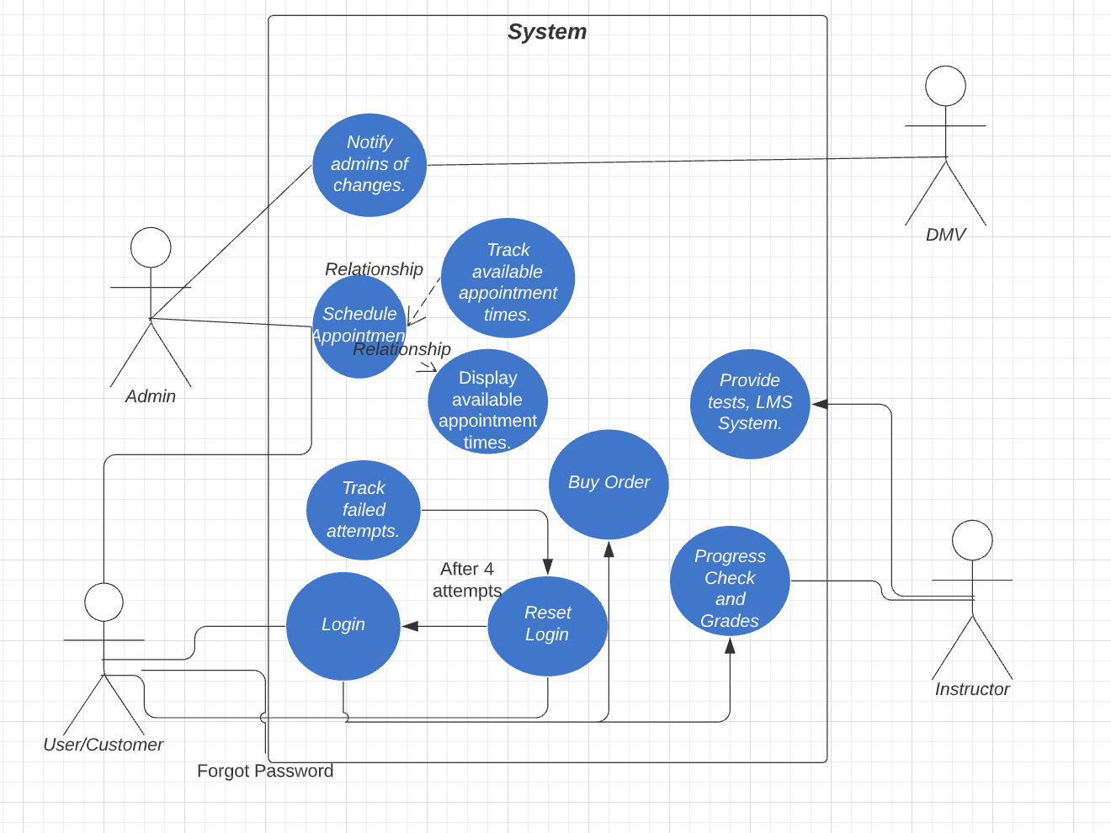

### UML Activity Diagrams

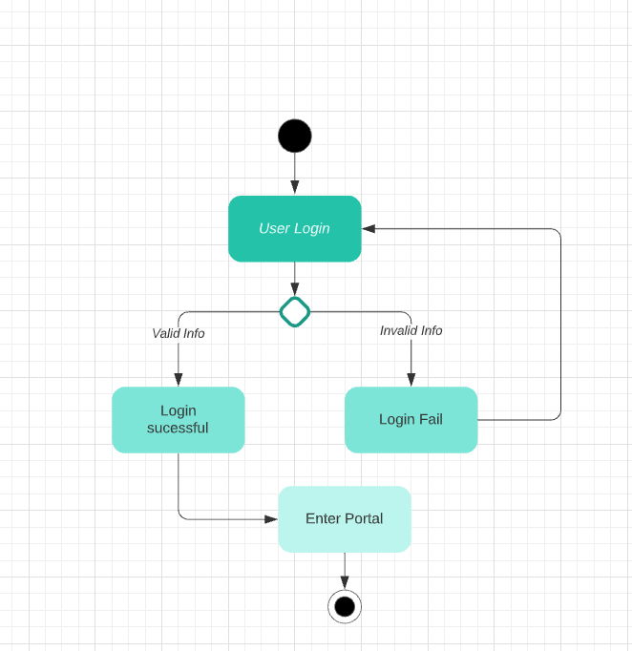

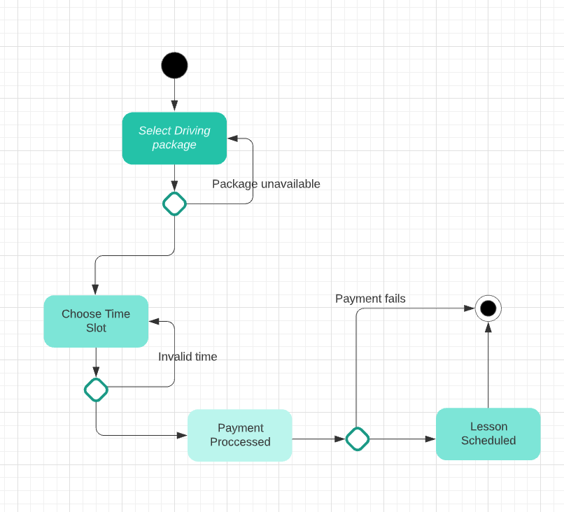

### UML Sequence Diagram

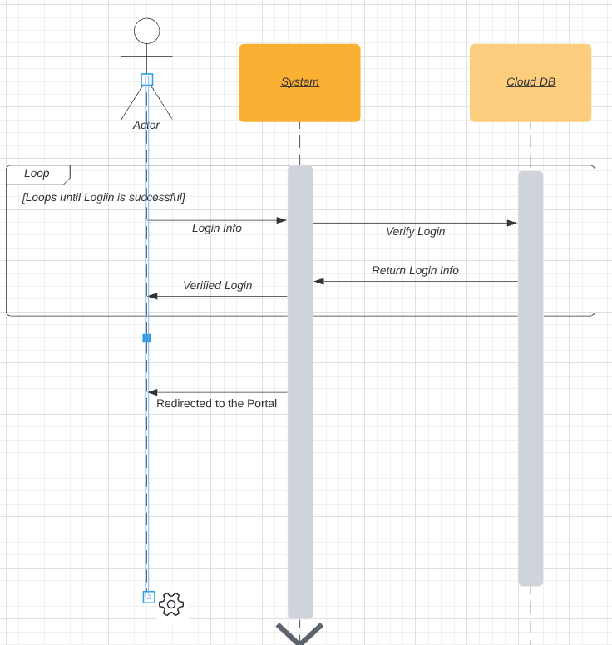

### UML Class Diagram

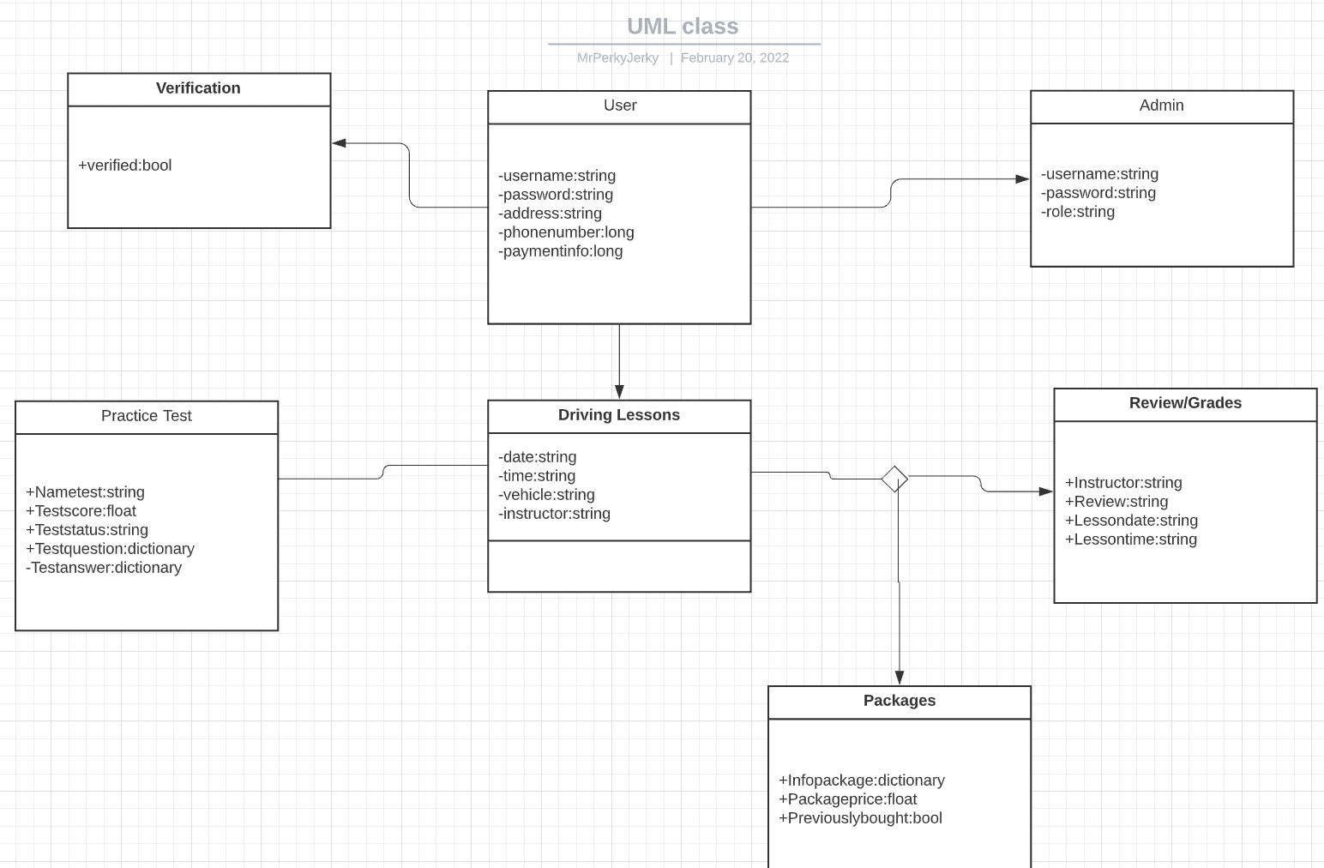

## Technical Requirements

*Phones aren’t as strong as computers, so we will have to account for that. Screen sizes should also be accounted for and most importantly of all no budget was said but everything should be fine provided a big problem doesn’t occur our time frame is roughly five months. It should be a web based application using a cloud base database. The cloud will have the login information, and the general code.*